Brealey, John
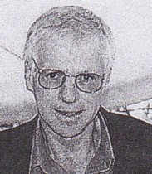
Graduated from Dwellingup Cadet School in 1970s. Worked for Forests Department at Harvey in mid 1970s. At Manjimup in late 1970s-80s. Promoted to Forester at Manjimup in 1988. Promoted to Field Manager Sharefarming in 1991.

